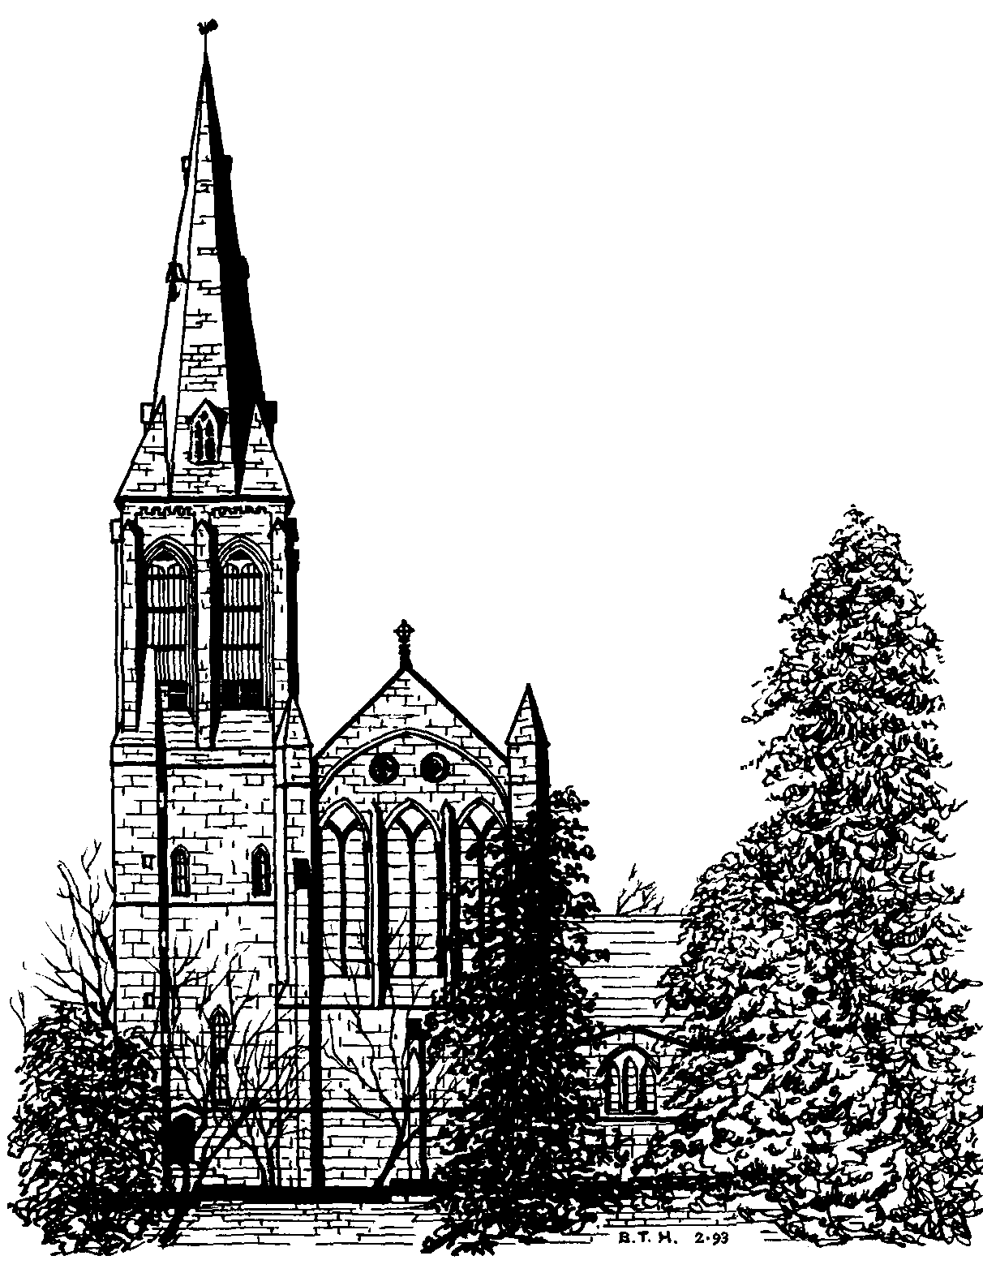
St. Margaret’s Church, Horsforth
Sponsoring the Floodlights
St. Margaret’s Church is a major feature of the Horsforth skyline and its award winning floodlighting enhances the attractiveness of the village at night. However, on average, over the year, it costs around £5.00 to run the floodlights for each evening.

You can help us to keep the floodlights on by sponsoring the running costs for an evening and using that to commemorate some personal or family event or anniversary - but your sponsorship can be anonymous if you wish.

Don’t forget that you need to make your request by the beginning of the month before your chosen date for the dedication to appear in the appropriate monthly Church magazine.

If you would like to sponsor the floodlighting, please complete the form below and pass it with your £5.00 donation to Eunice Glover in the Parish office.

Please use a separate form for each floodlighting occasion and make any cheques payable to “St. Margaret’s Church”.

Thank you for your kind contribution.

--------------------------------------------------------------------------------------------------------------------------------------

Name of Sponsor . . . . . . . . . . . . . . . . . . . . . . . . . . . . . . . . . . . . . . . . .

Date of Floodlighting . . . . . . . . . . . . . . . . . . . . . . . . . . . . . . . . . . . . . . .

Wording of Dedication for Magazine

Amount paid £ . . . . . . . . . . . . . . . . . Date paid . . . . . . . . . . . . . . . . . . .

Method of payment: Cash or Cheque [please delete as appropriate]

If you pay income tax, we can reclaim the tax you have paid on this donation for
gift aid it | Floodlighting. We shall reclaim tax automatically on behalf of Church members who give regularly to St. Margaret’s under the Gift Aid scheme.
If you are not a regular donor but would like us to reclaim the tax you have paid on your donation, please tick here and then write your full name and address including post code on the back of this sheet.
Thank you.

